“IS THERE A MEDICAL INTERPRETER
IN THE HOUSE?”
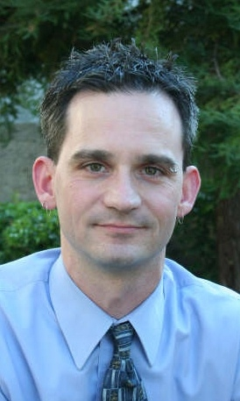
Workshop Presented by Todd Agan, CI/CT, BEI Master
Saturday, October 12, 2013, 9:00 a.m. – 5:00 p.m.
Sunday, October 13, 2013, 9:00 a.m. – 4:00 p.m.
Nail Technical Center (NTC), Rms. 120A & 120B
NOTE: Participants may register for Saturday only; however, participants registering for Sunday MUST attend Saturday’s session.
Medical interpreting is a high-consequence setting in which accuracy is the interpreter’s most important objective—but what things influence accurate interpretations? This two-day medical interpreting intensive will take a deeper look at the constructs that influence our accuracy as well as research and legislation that affect how we work as interpreters in healthcare.

Whether it is the type of appointment or the participants involved, interactive discussion will address considerations to effectively navigate the world of medicine. Activities will provide clarity to accurately conceptualizing and interpreting the medical interview and physical exam, with particular attention paid to anatomical structures and their location, as well as attempting to better develop interpreters’ understanding of medical terminology. Participants will also understand the importance of preparation and self-care, develop strategies for interpreting common procedures, and explore ethical and legal considerations that impact interpreters working in this high-stakes setting.

SATURDAY: Qualities, skills, and knowledge every medical interpreter should have; a closer look at various medical settings; accurately the medical interview & physical exam; immunizations.

SUNDAY: Anatomy; terminology; ethics/informed consent
Registration Fees CEUs
Workshop | Students | Non-Students |  | Credits
Saturday Only | $15 advance  $20 at the door | $50 advance/  $60 at the door |  | .7
Both Days | $25 advance  $30 at the door | $75 advance/  $80 at the door |  | 1.3
Make Check or Money Order Payable to: San Antonio College
  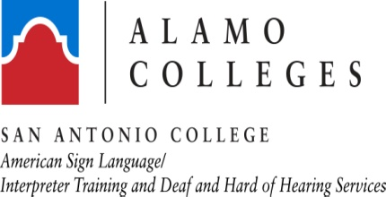  HOSTED BY  and |  |  |  |  | TODD AGAN is a full-time interpreter for a deaf internal medicine physician. He has devoted the past 15 years to specializing in medical interpreting, twelve of which were focused on interpreting for deaf medical professionals. As a result, Todd’s experience and knowledge present a rare insider’s view to medical interpreting. In addition, he is a part-time adjunct instructor in the San Antonio College Dept. of American Sign Language and Interpreter Training Program.
MAIL PAYMENT TO:
San Antonio College
Dept. of American Sign Language & Interpreter Training
1300 San Pedro Avenue, NTC 114
San Antonio, TX 78212-4299
Telephone: (210) 486-1106
Requests for Special Accommodations Must be Received No Later Than 3 Days Prior to the Workshop
(Cancellation Policy Available by Calling the ASL Dept.)
^{(Cut Along Dotted Line)}
“Is There A Medical Interpreter In The House?”
WORKSHOP REGISTRATION FORM
Name __________________________________________________________________________________________________________________

Contact Information _____________________________________________________________________________________________________
Please Indicate Which Workshop Day(s) You Are Attending
Saturday Only __________ Both Days _______
(Receipt will be provided at the door)

