Hands of Harvest ~ Live A Legacy, LLC ~ Vansickle Baptist Church

PRESENTS on October 25, 2014

“Interpreting and the Deaf Ministry”
Workshop Registration Form

Name: _______________________________________________________________________

Address: _____________________________________________________________________

E-mail: ______________________________________________________________________

Church Name: ________________________________________________________________

$15.00 on or before October 4th, 2014
$20.00 on or before October 11th, 2014
$25.00 on or before October 25th, 2014
(Full refund within one week of concert with written request.)

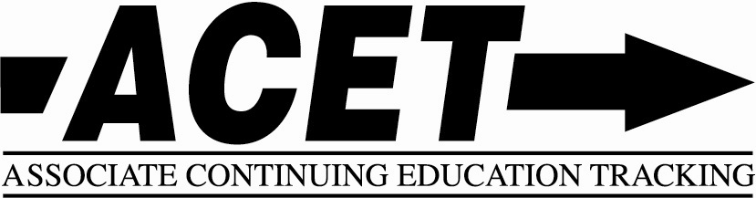

Amount enclosed: ____________

Make checks payable to: Live A Legacy, LLC
Please Mail to: Live A Legacy, LLC
9164 County Road 2584
Royse City, TX 75189
Workshop location: 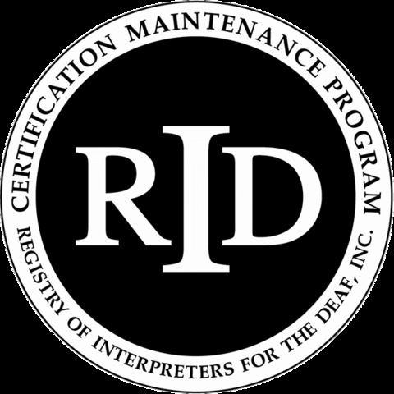
Vansickle Baptist Church 0.__ RID CEU’s
2181 CR 2246
Greenville, TX 75402

Workshop will be presented in sign; voice interpreting if needed.
Any other accommodations needed please contact Trisha Hicks at 850-628-1553 (voice/text)
e-mail patriciamhicks@gmail.com

"FRID is an approved RID CMP Sponsor for Continuing Education Activities.”
Texas BEI CEU Pending

