St. Ignatius Deaf Ministry Spring Retreat
March 24-26, 2017
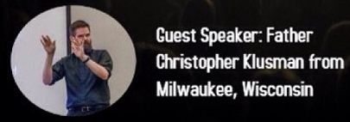

Friday, March 24th, 2017: 6-8 pm: Welcome & Dinner
Saturday, March 25th: 8 am-5 pm: Presentations, discussions, rosary and confession, Breakfast and Lunch included. Dinner with Fr. Klusman at own expense
March 26th: 9 to 5 pm : Presentation, Breakfast included, Lunch on your own. Mass at 3 pm with Fr. Klusman
Registration Form
Registration Fee is $25.00. Cash or check only. Make check payable to: St. Ignatius Deaf Ministry

First & Last Name

Street Address

City State Zip

Phone Number

Email

Dietary Needs: Special Needs:

_______Vegan ________Gluten Free _______Deaf/Blind interpreter
_______Other: Explain__________________
____________________________________

St. Ignatius Martyr Catholic Church: Deaf Ministry
2309 Euclid Ave, Austin, TX 78704
Contact: Sarah Bannon, deafministry@st-ignatius.org

