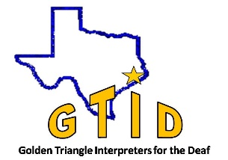
Golden Triangle Interpreters for the Deaf
March 24 – 25, 2017
Trix Bruce Registration

~ Accommodations ~

The workshops and performance will be presented in American Sign Language.

Sign-to-Voice Interpreters
will not be provided.

~ Refunds ~

Refund requests must be in writing, sent to the PO Box and postmarked by March 15, 2017. A 10% administration fee will be assessed on ALL refunds.
No refunds, except for medical emergencies, will be issued past April 25, 2017.

~ Registration/Payment ~

Mail
Send registration forms and checks (payable GTID) to:
GTID
PO Box 22864
Beaumont, TX 77720-2864

Electronic
Use gtid@gtid.tsid.org
To submit form/RSVP and payment via PayPal.

~ Questions ~

For questions or more information, contact:
GTID@gtid.tsid.org

Name: _____________________________________________

Address: ___________________________________________

City: ______________________ State: ____ Zip: ________

Phone: ______________________ _____________________

Email: _____________________________________________

REGISTRATION OPTIONS
Combo Ticket (Includes both workshops and performance)
Feb. 15 Mar. 15 Door
Student / Non - CEUs $60 $70 $80

Certified / CEUs $120 $140 $160

A la Carte Workshops and Performance

Friday Student/Non-CEUs @ 30 each x_____= $_____

Friday Cert/CEUs @ $60 x_____= $_____

Saturday Student/Non CEUs @ $50 x_____= $_____

Saturday Cert/CEUs @ $100 x_____= $_____

Saturday Performance @ $20 x_____= $_____

Payment Due
Combo Ticket $__________
A la Carte (total from above) $__________

Grand Total $__________

PAYMENT OPTIONS
Checks and PayPal accepted prior to March 15, 2017.
Cash, Debit and Credit accepted at the door.

